

AUGUST 2018 EXAMINATION

School of InfoComm Technology

(Diploma in Information Security & Forensics)

(Diploma in Information Technology)

## Level 2 Time Allowed: 2 Hours

# **NETWORKING INFRASTRUCTURE**

# **(011789)**

INSTRUCTIONS TO CANDIDATES:

**1. Check carefully to ensure you are sitting for the correct paper.**

2. There are FIVE questions. Answer ALL questions.

3. All questions carry equal marks.

4. Begin each question on a separate page.

5. This paper consists of 8 pages including this cover page. Check carefully to make sure your set is complete.

There are FIVE questions. Answer **ALL** questions.

**QUESTION 1** (20 marks)

ABB Pte Ltd is a manufacturing company with its sales office located at level 1 and admin office at level 20 within the same building. The following devices are deployed:

• At level 1 (Sales office)

* A switch connected to 5 workstations and 1 wireless access point to serve 10 laptop users.
* A router which provides an Internet connection.
  + A file server and a web server which hosts in-house applications.
* At level 20 (Admin office)
  + A switch connected to 20 workstations.
* Access to the Internet goes through the Sales office.

(a) Draw a structured cabling diagram to illustrate the above network and clearly label the following:

1. SIX components of the EIA/TIA 568 Structured Cabling System.

(6 marks)

1. ALL equipment and their connectivity.

(5 marks)

(b) As a Network Administrator, you suggested that an additional uplink between level 1 and level 20 be installed to prevent a single point of failure.

1. After installation of the additional link, a workstation in the admin office was not able to communicate with another workstation in the Sales office. Identify and briefly explain what could have caused the problem.

(3 marks)

(ii) How would the switches resolve the problem in (b)(i)? Explain and illustrate your answer with the aid of a well-labelled diagram.

(6 marks)

**QUESTION 2** (20 marks)

1. Figure 2(a) shows a network of routers and the Cisco routing commands executed on Router A.

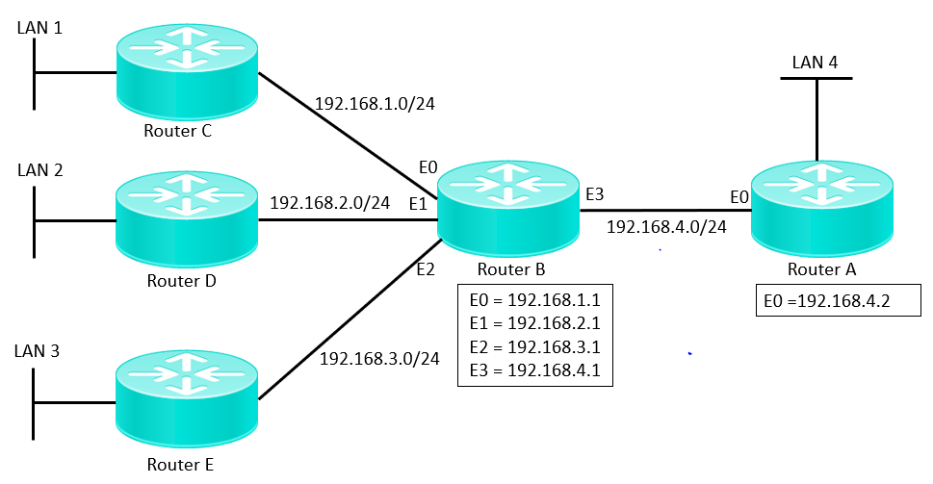

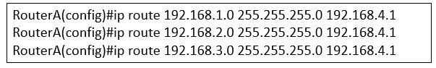

Figure 2(a): Network of routers and routing commands executed on Router A

1. There is another method to specify the router commands besides using next-hop IP address as shown in Figure 2(a). Rewrite the commands to illustrate this method.

(2 marks)

1. The router commands shown in Figure 2(a) can be replaced by a single command specifying a default route.

What is a default route? State the router command to specify the default route.

(3 marks)

1. State any TWO advantages of using the network routing shown in Figure 2(a).

(4 marks)

**QUESTION 2** (cont.)

1. Figure 2(b) shows a network of routers. All their interfaces are configured with subnet mask of 255.255.255.0. The IP addresses of the routers’ interfaces and bandwidth of the network links are also shown.

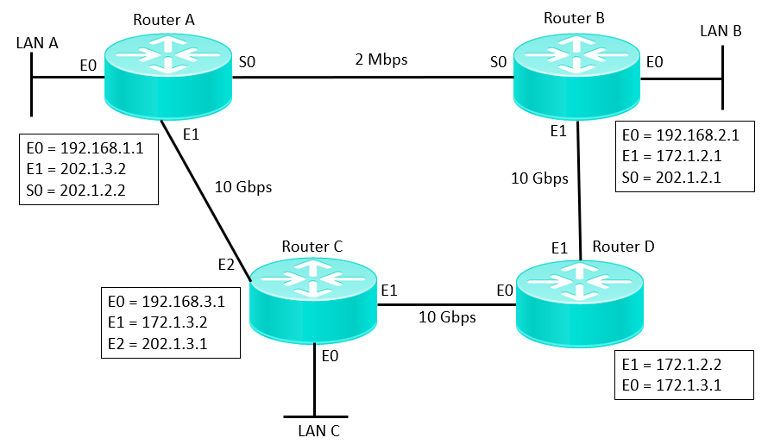

Figure 2(b): Network of routers

1. Assuming that RIP is used as the routing protocol, determine the content of the routing table in Router A when the network has converged after the exchange of routing information.

(Redraw and complete the table in the Answer Booklet)

|  |  |  |
| --- | --- | --- |
| Destination Network Address | Next Hop IP address or Interface | Metric (hop count) |
|  |  |  |
|  |  |  |
|  |  |  |
|  |  |  |
|  |  |  |
|  |  |  |
|  |  |  |

(7 marks)

1. A connectivity test using tracert command was issued from a PC in LAN A to another PC in LAN B when RIP was used as a routing protocol. RIP was then replaced with OSPF routing protocol. When the network was converged, another similar tracert test was conducted from the PC in LAN A to the PC in LAN B.

Briefly explain the results of the two tests in terms of the route taken by the ICMP tracert packets and their round-trip response times. The OSPF default cost metric for the different bandwidths are provided in Table 2(b).

|  |  |
| --- | --- |
| **Bandwidth** | **Default Cost Metric** |
| 10 Gbps | 1 |
| 2 Mbps | 48 |

Table 2(b): OSPF default cost metric

(4 marks)

**QUESTION 3** (20 marks)

1. TSA Enterprise is using Class C IP addresses with Network ID 196.40.50.0. As the network administrator, you are tasked to provide an IP addressing scheme for the Sales, Admin and Finance departments respectively.

(i) Determine the minimum number of subnet bits. Show your working clearly.

(2 marks)

(ii) Determine the maximum number of hosts per subnet. Show your working clearly.

(2 marks)

(iii) Determine the first three usable subnets and their IP address ranges to complete the table below. Assume that subnet zero and subnet all ones are NOT allowed. Show your working clearly.

(Redraw and complete the table in the Answer Booklet)

(6 marks)

|  |  |  |  |
| --- | --- | --- | --- |
|  | Network ID (196.40.50.0) | Subnet Bits | Host IP Range |
| 1st Usable Subnet | 196.40.50.32 | 001 | 33-62 |
| 2nd Usable Subnet | 196.40.50.64 | 010 | 65-94 |
| 3rd Usable Subnet | 196.40.50.96 | 011 | 97-126 |

Table 3(a)(iii): Usable Subnets

1. Determine the new subnet mask for this network and represent the new subnet mask with IP prefix notation.

(2 marks)

**QUESTION 3** (cont.)

1. According to Figure 3(b), the network administrator was configuring VLANs for two layer 3 switches in level 1 and level 2 of a building respectively. All the devices have been configured with the IP addresses as shown.

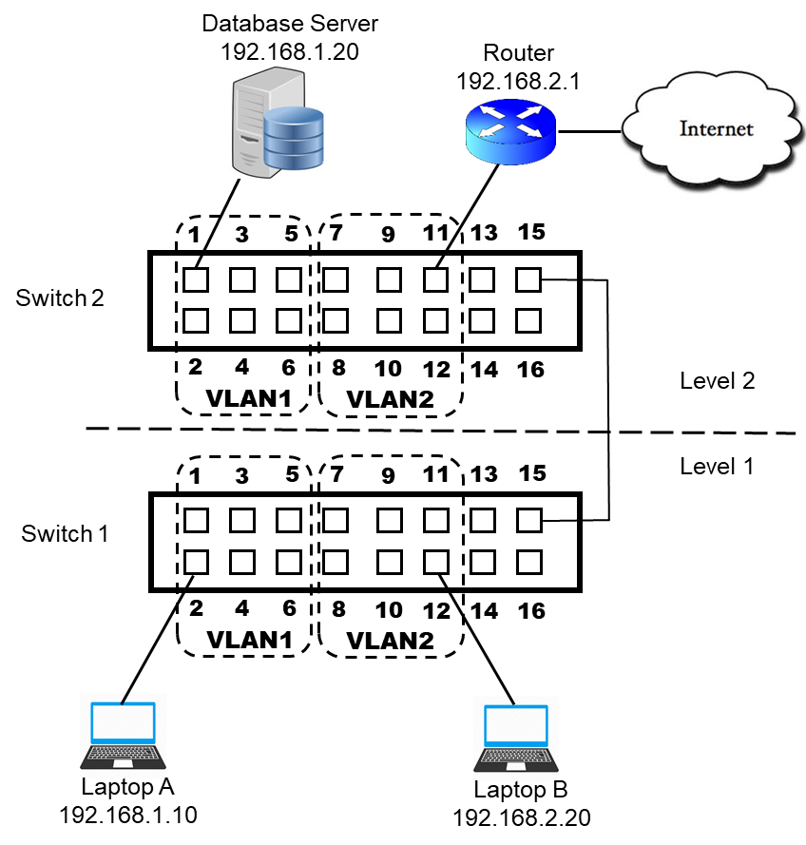

Figure 3(b): VLAN Configuration Plan

1. After completing the first step of assigning VLAN memberships to the switch ports, the Network Administrator would like to test the network connectivity from Laptop A to Laptop B. List the command to perform this. Will the test be successful? Explain your answer.

(2 marks)

1. The Network Administrator connected both switches at level 1 and 2. Laptop B could not access the Internet. Assuming that the configurations of Laptop B and router are correct, explain how the switches could be configured to resolve the connection issue of Laptop B.

(2 marks)

1. Which command should the Network Administrator issue to find out the default gateway of Laptop B? What would be the result of the query?

(2 marks)

1. Laptop B is not able to access the Database Server even after completing step (i) and (ii). Suggest and explain ONE solution to allow this communication.

(2 marks)

**QUESTION 4** (20 marks)

Freeware Pte Ltd is a multinational software development company and its registered domain name is freeware.sg. It has 2 branch offices in Singapore, each has a domain name registered as child domain under freeware.sg. One office is located at Jurong and the other located at Clementi. Recently, Freeware Pte Ltd bought over a competitor, Payware Pte Ltd, with an existing domain name Payware.com. Payware.com has 2 offices located in Brunei and Vietnam respectively.

Both companies will keep their domain names, with administration coming under the Freeware Pte Ltd’s network.

(a) Explain what an Active Directory is and why it is important.

(2 marks)

(b) With the aid of a well-labelled diagram, propose a multiple-domain Active Directory (AD) structure for the network. Your answer should clearly label the AD components: domain, tree and forest.

(6 marks)

(c) With reference to the AD structure you have proposed, suggest the suitable location(s) where the domain controller(s) should be installed. Explain and justify your answer.

(2 marks)

(d) During the process of the merger, one of the domain controllers failed. All users were unable to log on to the network to access network resources. Suggest ONE way to improve the reliability of the network.

(2 marks)

(e) After the successful merger, there is a request to allow access to a shared printer located at Freeware domain for all Sales users in both Freeware and Payware domains. This printer is located at the Jurong office of Freeware domain. List down the group strategy to allow Sales users from both domains to access the shared printer.

(8 marks)

**QUESTION 5** (20 marks)

(a) In a Windows Active Directory domain, two security groups, Marketing Group and HR Group, were created on an Active Directory server named ADServer.

A folder named Project was created on this server’s C directory. The NTFS and share-level permissions assigned to the security groups and a Windows user named Jack are shown in Table 5(a).

|  |  |  |
| --- | --- | --- |
| **Users & Groups** | **NTFS Permissions** | **Shared Folder Permission** |
| HR Group | *Full Control* | *Full Control* |
| Marketing Group | *Allow Read* | *Deny Full Control* |
| Jack | *Allow Read*  *Allow Write* | *Full Control* |

Table 5(a): NTFS and Shared Folder Permissions for Project folder

1. What is/are Jack’s effective permission(s) on Project folder when he is accessing it locally on the Active Directory server and when he is accessing it across the network from another computer in the same Windows domain? Explain your answer.

(4 marks)

1. If Jack is added as a member to both HR and Marketing groups, what would be his effective permission(s) on the Project folder when he is accessing it locally on the Active Directory server and when he is accessing it across the network from another computer in the same Windows domain? Explain your answer.
2. marks)
3. State how the Project folder can be configured as a hidden share. Explain how Jack can access this hidden folder over the network.

(2 marks)

(b) An Administrator is required to deploy a Windows software application named QuickPay to a specific group of computers automatically in a Windows Active Directory domain. He is also required to make another software named HR-App available for a specific group of Windows users so that these users can choose whether to install it on their computers. The tasks can be accomplished using group policy and organizational unit (OU) objects.

1. Explain the purpose of group policy and an organizational unit (OU) object.

(4 marks)

1. Briefly describe the steps required to accomplish the above-mentioned tasks in (b).

(5 marks)

1. Besides deploying software applications, identify any TWO other usage of group policy.

(2 marks)

** END OF PAPER **